# Ads – SPA with AngularJS Lab

The **goal of this lab** is to continue the development of the Online Ads AngularJS application: **publish new ad**.

## Publish New Ad

1. Add "Publish New Ad" route in **app.js**:

|  |
| --- |
| **app.js** |
| $routeProvider.when(**'/user/ads/publish'**, {  **templateUrl**: **'templates/user/publish-new-ad.html'**,  **controller**: **'UserPublishNewAdController'** }); |

5 score

1. Implement **global authorization check** to avoid anonymous site visitors to access user screens:

|  |
| --- |
| **app.js** |
| app.run(**function** ($rootScope, $location, authService) {  $rootScope.$on(**'$locationChangeStart'**, **function** (event) {  **if** ($location.path().indexOf(**"/user/"**) != -1 && !authService.isLoggedIn()) {  *// Authorization check: anonymous site visitors cannot access user routes* $location.path(**"/"**);  }  }); }); |

5 score

1. Create the **"Publish New Ad" form** (without the image upload for simplicity):

|  |
| --- |
| **publish-new-ad.html** |
| ***<div class="box">***  ***<h2>Publish New Ad</h2>***  ***<p>***  ***<label for="title">Title:</label>***  ***<input type="text" id="title" ng-model="adData.title" required />***  ***</p>***  ***<!-- TODO: add “text” field -->***  ***<p>***  ***<label for="category">Category:</label>***  ***<select id="category" ng-model="adData.categoryId">***  ***<option value="null">(None)</option>***  ***<option ng-repeat="c in categories" value="{{c.id}}">{{c.name}}</option>***  ***</select>***  ***</p>***  ***<!-- TODO: add “town” drop-down field -->***  ***<p>***  ***<a ng-click="publishAd(adData)" class="button">Publish</a>***  ***<a href="#/user/ads" class="button">Cancel</a>***  ***<p>***  ***</div>*** |

10 score

1. Implement the **UserPublishNewAdController.js**:

|  |
| --- |
| **UserPublishNewAdController.js** |
| **'use strict'**;  ***app***.*controller*(**'UserPublishNewAdController'**,  **function** ($scope, $location, townsService, categoriesService,              userService, notifyService) {        $scope.**adData** = {**townId**: **null**, **categoryId**: **null**};        $scope.**categories** = categoriesService.getCategories();        $scope.**towns** = townsService.getTowns();        $scope.publishAd = **function**(adData) {            userService.createNewAd(adData,  **function** *success*() {  *//* ***TODO: show “success” info message***  $location.path(**"/user/ads"**);                },  **function** *error*(err) {  *//* ***TODO: show error message***  }            );        };    }  ); |

Don't forget to load the **UserPublishNewAdController.js** in your **index.html**.

10 score

1. Define a service **userService** that will implement operations for logged in users:

|  |
| --- |
| **userService.js** |
| **'use strict'**;  ***app***.**factory**(**'userService'**,  **function** ($http, baseServiceUrl, authService) {  **return** {  createNewAd: **function** (adData, success, error) {  **var** request = {  **method**: **'POST'**,  **url**: baseServiceUrl + **'/api/user/ads'**,  **headers**: authService.getAuthHeaders(),  **data**: adData  };  $http(request).success(success).error(error);  },   getUserAds: **function** (params, success, error) {  **var** request = {  **method**: **'GET'**,  **url**: baseServiceUrl + **'/api/user/ads'**,  **headers**: authService.getAuthHeaders(),  **params**: params  };  $http(request).success(success).error(error);  },   deactivateAd: **function** (id, success, error) {  *//* ***TODO*** },   publishAgainAd: **function** (id, success, error) {  *//* ***TODO*** }  }  } ); |

Don't forget to load the **userService.js** in your **index.html**.

Note that the user service works for logged in users only. It relies on **authService.getAuthHeaders()** function to prepare the bearer authorization headers.

10 score

1. Test your application to ensure that **"Publish Advertisement" functionality works correctly**:

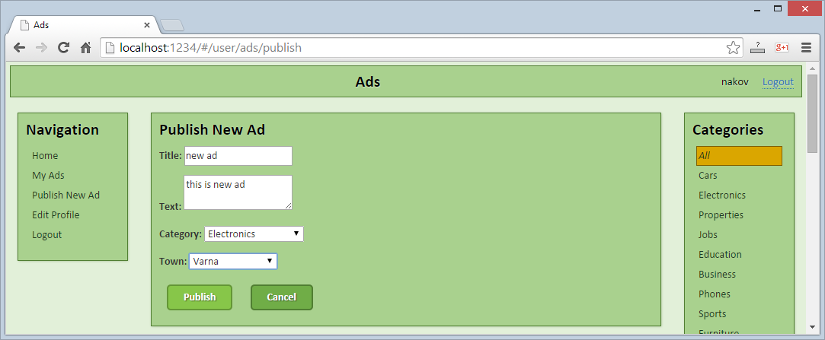

* + Check also the **incorrect "Publish Ad"** functionality:

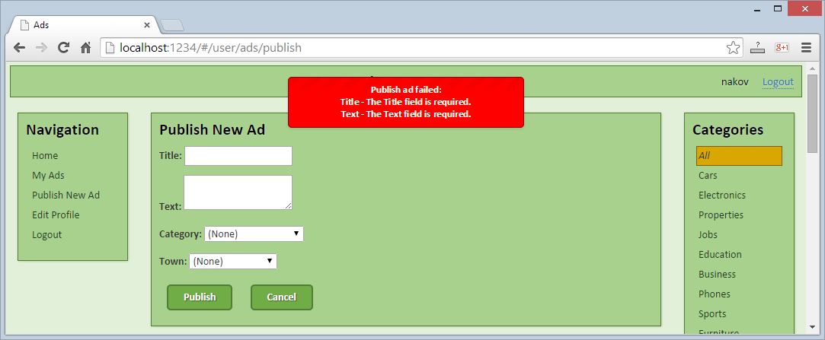

* + Try to access the **"Publish Ad"** functionality without login (after logout), by typing directly the URL: <http://localhost:1234/#/user/ads/publish>. You should be redirected to the login screen.
  + Check for errors at the Web browser's development console:

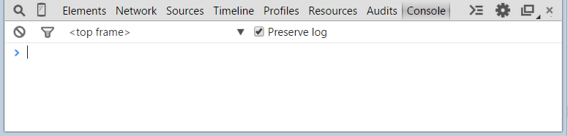

10 score

1. Implement "**Image Upload with Live Preview**" functionality.

First, add the following code in the **"Publish New Ad" view**:

|  |
| --- |
| **publish-new-ad.html** |
| <**p**>    <**label for="image"**>Image:</**label**>    <**input type="file" id="image"**  **onchange="angular**.**element**(**this**).scope().fileSelected(**this**)**"** />    <**div class="image-box"**>        <**p**>Image Preview</**p**>    </**div**>  </**p**> |

Second, add the following code in the **UserPublishNewAdController**:

|  |
| --- |
| **UserPublishNewAdController.js** |
| $scope.fileSelected = **function**(fileInputField) {  **delete** $scope.**adData**.**imageDataUrl**;  **var** file = fileInputField.**files**[0];  **if** (file.type.match(/image\/.*/)) {  **var** reader = **new FileReader**();  reader.onload = **function**() {  $scope.**adData**.**imageDataUrl** = reader.**result**;  *$*(**".image-box"**).html(**"<img src='"** + reader.**result** + **"'>"**);  };  reader.readAsDataURL(file);  } **else** {  *$*(**".image-box"**).html(**"<p>File type not supported!</p>"**);  } }; |

10 score

1. Test your application to ensure that **"Image Upload with Live Preview" functionality works correctly**:

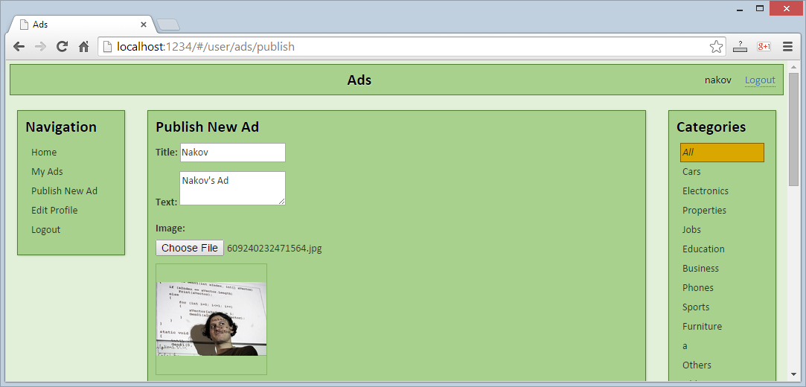

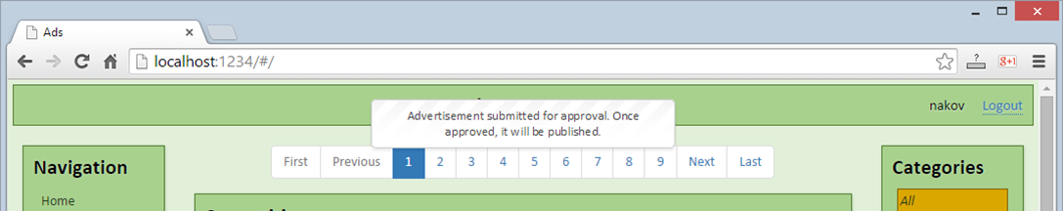

5 score